U S E R M A N U A L

HDMI Audio (SPDIF+R/L) Extractor

（4K、ARC、EDID Setting Audio Extractor）

Enjoy the vivid world!

INTRODUCTION

Dear customer
Thank you for purchasing this product. For optimum performance and safety, please read these instructions carefully before connecting, operating or adjusting this product. Please keep this manual for future reference.

Our series of HDMI converters, switches, extenders, matrixes and splitters are designed to make your A/V device use more convenient, more comfortable, more productive and more cost-efficient.

The audio extractor is one device that can support 3D、 4KX2K、ARC and it allows the one HDMI or one MHL source input and one HDMI output connected to one HD Display (like TV or Projector) and extract the audio to one SPDIF audio out+One LR Stereo audio out. Also the device supports ARC function.

Our devices offer solutions for noise, space and security concerns, data center control, information distribution, conference room presentation, school and corporate training environments.

FEATURES
- One HDMI input converter to one HDMI+ One SPDF+ One LR Audio Out
- Output audio support: SPDIF+R/L analog Audio Output
- Support Full HD 1080P, Full 3D,4K*2K resolution
- Support ARC Function: Without adding one extra HDMI Cable, it can reverse the audio to the AV Amplifier by HDMI Cable connection with HD TV while the HD TV receive the audio and video content.
- HDMI working in dual mode, can reduce the number of ports
- HDMI to achieve the synchronization of audio signal separation. There are ADV /
2.0CH / 5.1CH three kinds of audio mode options
- LED indication: when source or sink is working, LED relative to is light.
- No loss of quality
- Installs in minutes
- Need DC5V/1A power supply

The accessories with the machines lists as picture：

1、5V power adapter 1pcs
2、User manual 1pcs

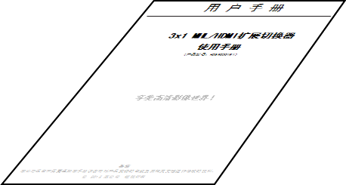
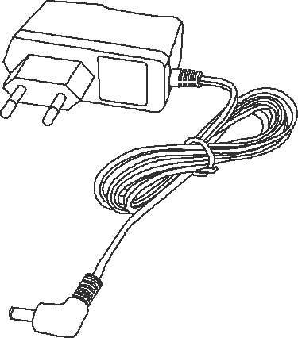

Physical Connection Showing Picture：

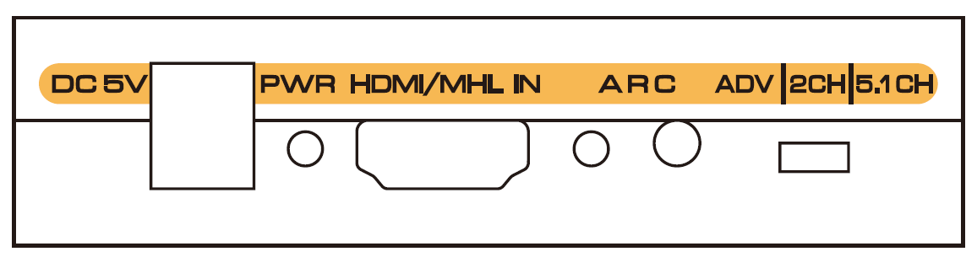
Figure 1.0 Front Panel Showing Picture
DC5V: 5V DC-DC Power Interface
PWR：Power Led Status Light
HDMI/MHL IN：HDMI/MHL dual mode input ports
GREEN LED：ARC Led Status Light
ARC：ARC Function On/Off Key
SWITCH：Switch button for Audio output mode, it can choose 5.1CH,2.0CH, ADV [Advance Audio] three kinds of audio output mode by circulate switching(When switch to 5.1CH audio mode output, the Digital audio signal receiving terminal must can support DTS/DOLBY-AC3 decode, or the input D audio signal receiving terminal will have no sound output; If need the audio signal receiving terminal can output the audio, pls switch to 2CH audio mode. When audio output switch to the ADV [Advance Audio] mode, the audio output format will be decided by the audio signal receiving machine audio decode ability. The splitter will output 7.1 channel audio signal while the output end connects the AV amplifier with HDMI port that support 7.1 channel audio decode.(the HD Source signal itself is 7.1 channel)

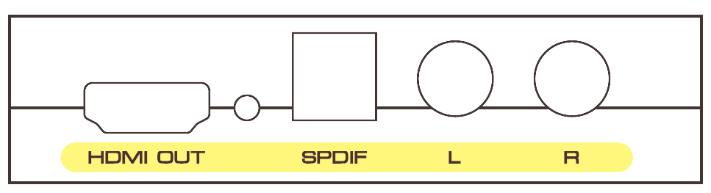
Figure 1.1 rear panel showing picture

HDMI OUT: HDMI output interface
GREEN LED：HDMI output led status light
SPDIF：SPDIF optical Output
L/R：Analog Sound Track(L/R) Output

Operating and Connecting：
- To use the HDMI cable to connect the HD Source with the HDMI input port of the converter or to use one MHL TO HDMI Cable to connect the MHL device with the HDMI input port of the extractor
- To use one HDMI Cable to connect the extractor HDMI output port with the HD Display.
- To use one audio cable to connect the extractor R/L port with the audio equipment.
- To use the optical cable to connect the SPDIF port with the audio equipment.
- To press the ARC switch key to on/off the ARC function.
- To connect the extractor with 5V DC power adaptor.

SPECIFICATIONS:

HDMI resolution …………………… ……...24/50/60fs/1080p/1080i/720p/576p/576i/480p/480i
Support video color format …………………………..…..………….24bit/deep color 30bit,36bit
Audio output……………………………………………………………………………. L/R+SPDIF
Max bandwidth………………………………………………………….………………….300MHz
Max baud rate…………………….………………….………………….………………..9.0Gbps
Input/Output TMDS signal ………….……………………………….……0.5~1.5Volts p-p(TTL)
Input/Output DDC signal ……………………………………………..………… 5Volts p-p (TTL)
Input cable distance..…... ………………………. ….…..≤15m AWG26 HDMI standard cable
Output cable distance……………………………….…...≤20m AWG26 HDMI standard cable
Max working current…………………………………………………………………………500mA
Power adapter format…………….…..Input: AC (50HZ, 60HZ) 100V-240V; Output: DC5V/1A
Operating Temperature range……..…………….………………………………… (-10 to +55℃)

Storage Temperature range…………………………………………………………… -20 to +60℃
Operating Humidity range………………………….….……….10 to 90%RH (No Condensation)

Storage Humidity range………………………….….……….…5 to 95%RH (No Condensation)
Dimension (L x W x H) ……………………………….……………………84.5X61.8X21 (mm)
Weight…..………………………………………………………..…….……………………..…135g

Notes:
Pls use the machine as the instruction listed to keep the long use lifetime of the machine.
- The machine should be placed at the spot far from the Damp, High-Temperature, Dusty, Erosive, and oxidative environment.
- All parts will be free from the strong shake, hit, fall.
- Touching the power adaptor with the wet hands is prohibited.
- Pls hold the power adaptor head and do not pull the power cord when cut off from the socket.
- Pls turn the power off when the machine is not used for long time.
- Pls do not open the cover and do not touch the inside parts.
- Pls use the original factory power adaptor.

Before power on, pls check the connection line carefully. And make sure that all interfaces are normally connected. The common trouble shooting way shows below:

Serial NO | Trouble Description | Cause and Ways to deal with
1 | Non-Power-Connected | 1、Check if the power adaptor head is truly and correctly inserted the power socket.  2、Check the power switch if it is in on status.
2 | No Picture | 1、Pls to make sure that the TV is on and has been connected with the machine.  2、To check if the signal source is on and well connected.  3、Check the system connection quality.  4、Check if the line is all good quality.  5、Check the cable quality
3 | Obscure Picture | 1、To try again to connect the cable to be free from the unsuccessful connection.  2、HDMI Cable Quality
4 | No sound | 1、Please confirm the setting position of audio mode switch

